Steps to Execute the Application

1. In BTP Cockpit -> dev space -> SAP HANA CLOUD -> create HANA Cloud DB instance

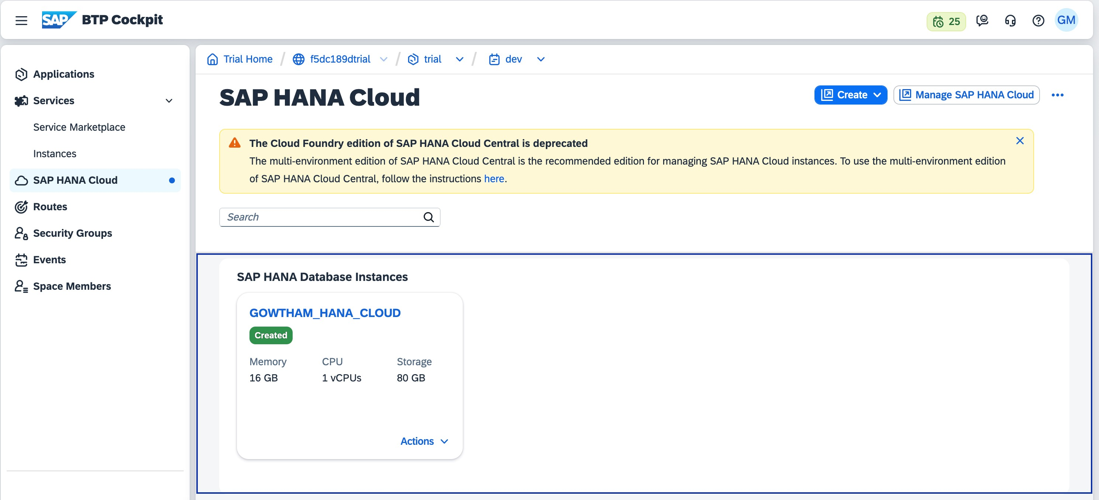

Make sure the cloud db instance is up and running.

1. open git hub and select repo [Gowtham_CAPM_FullStack](https://github.com/ergowthamraja/Gowtham_CAPM_FullStack) 3. copy the url "https://github.com/ergowthamraja/

Gowtham_CAPM_FullStack.git" from git hub repository

4

.

clone to display the project

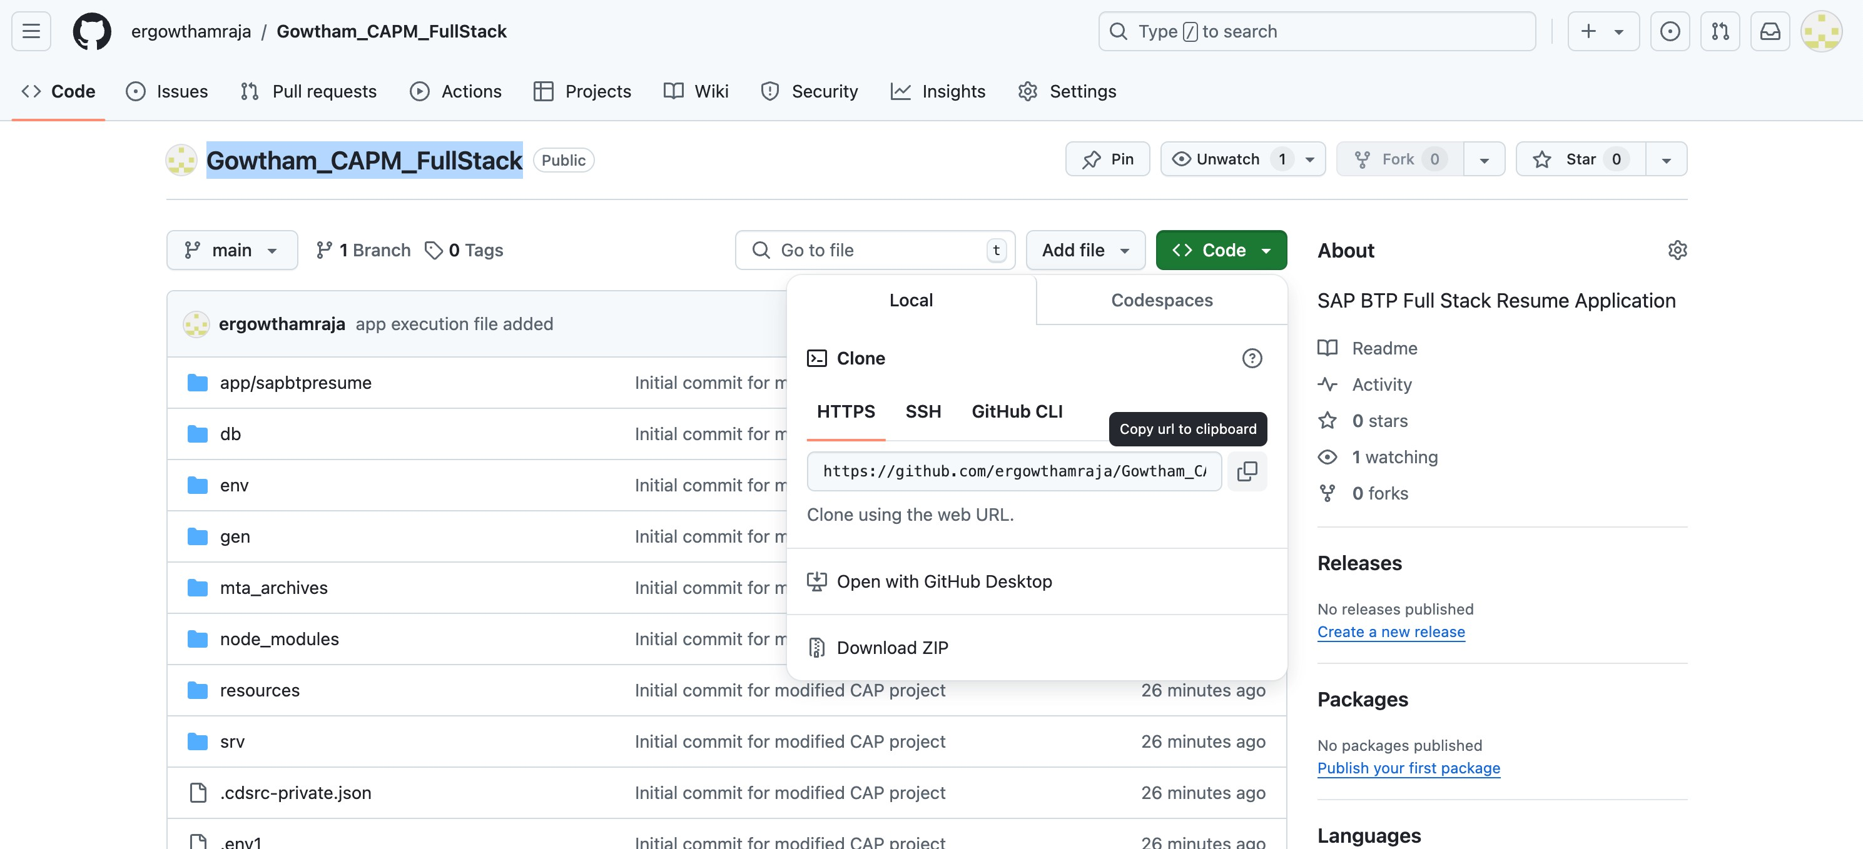

- no need to add npm install because its imported already from git repository

5. Right click the project in integrated terminal and execute below CLI

cds add hana npm add hdb --save cds build --production

– Make sure the app is working by executing CLI cds watch

5. Once the app works, deploy the app in CF

* Right click mta.yaml -> build. This will create mta_archives folder and .mtar file inside.

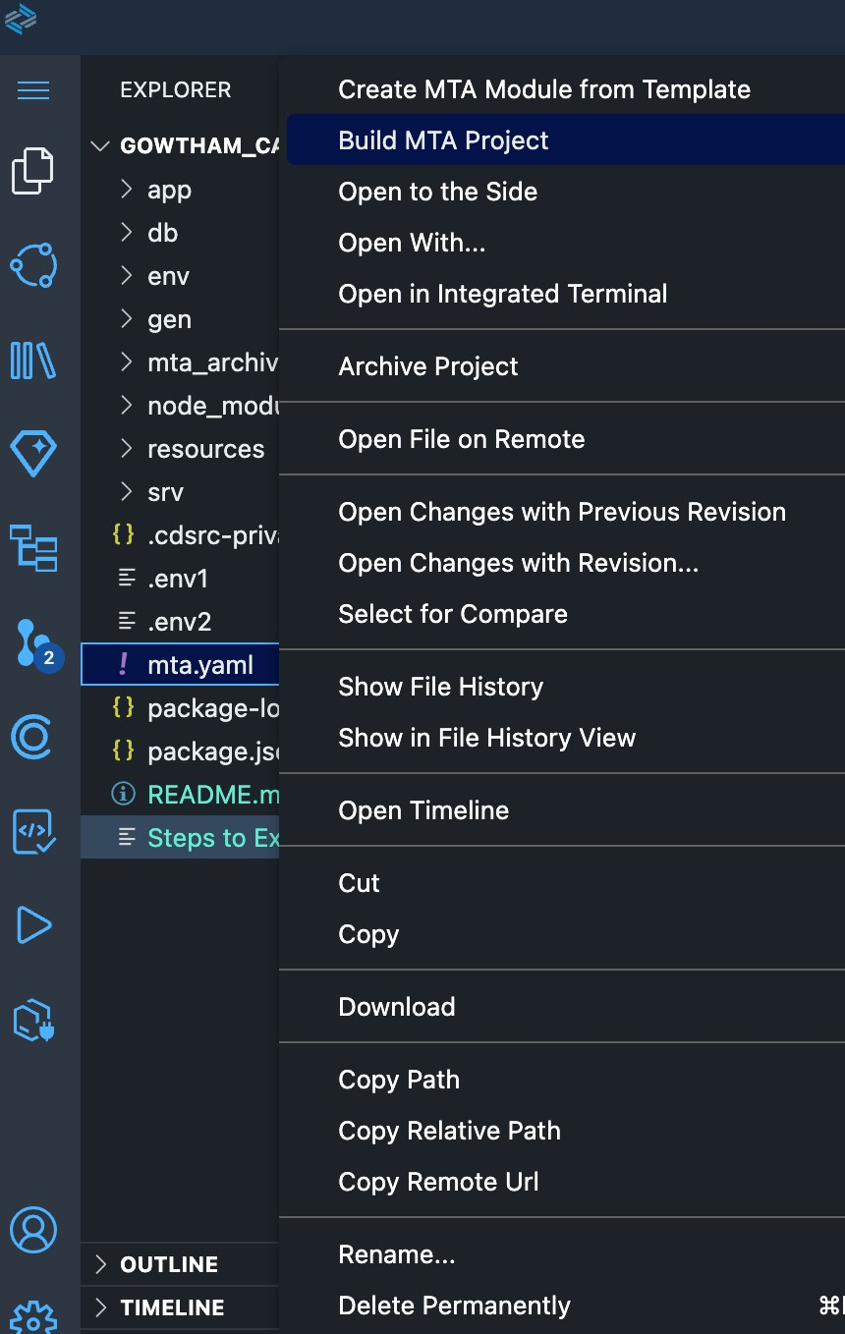

* Right click the .mtar file and deploy

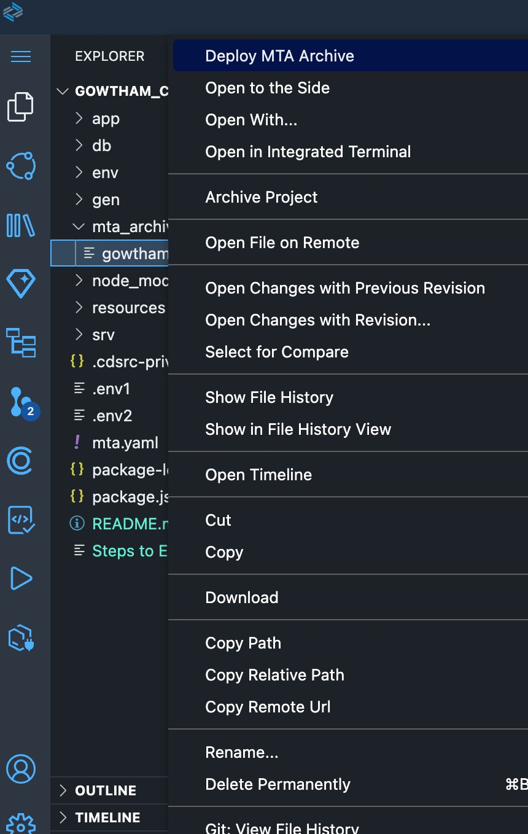

6. Once deployed in CF

– Open hana cloud db and check whether the tables in place

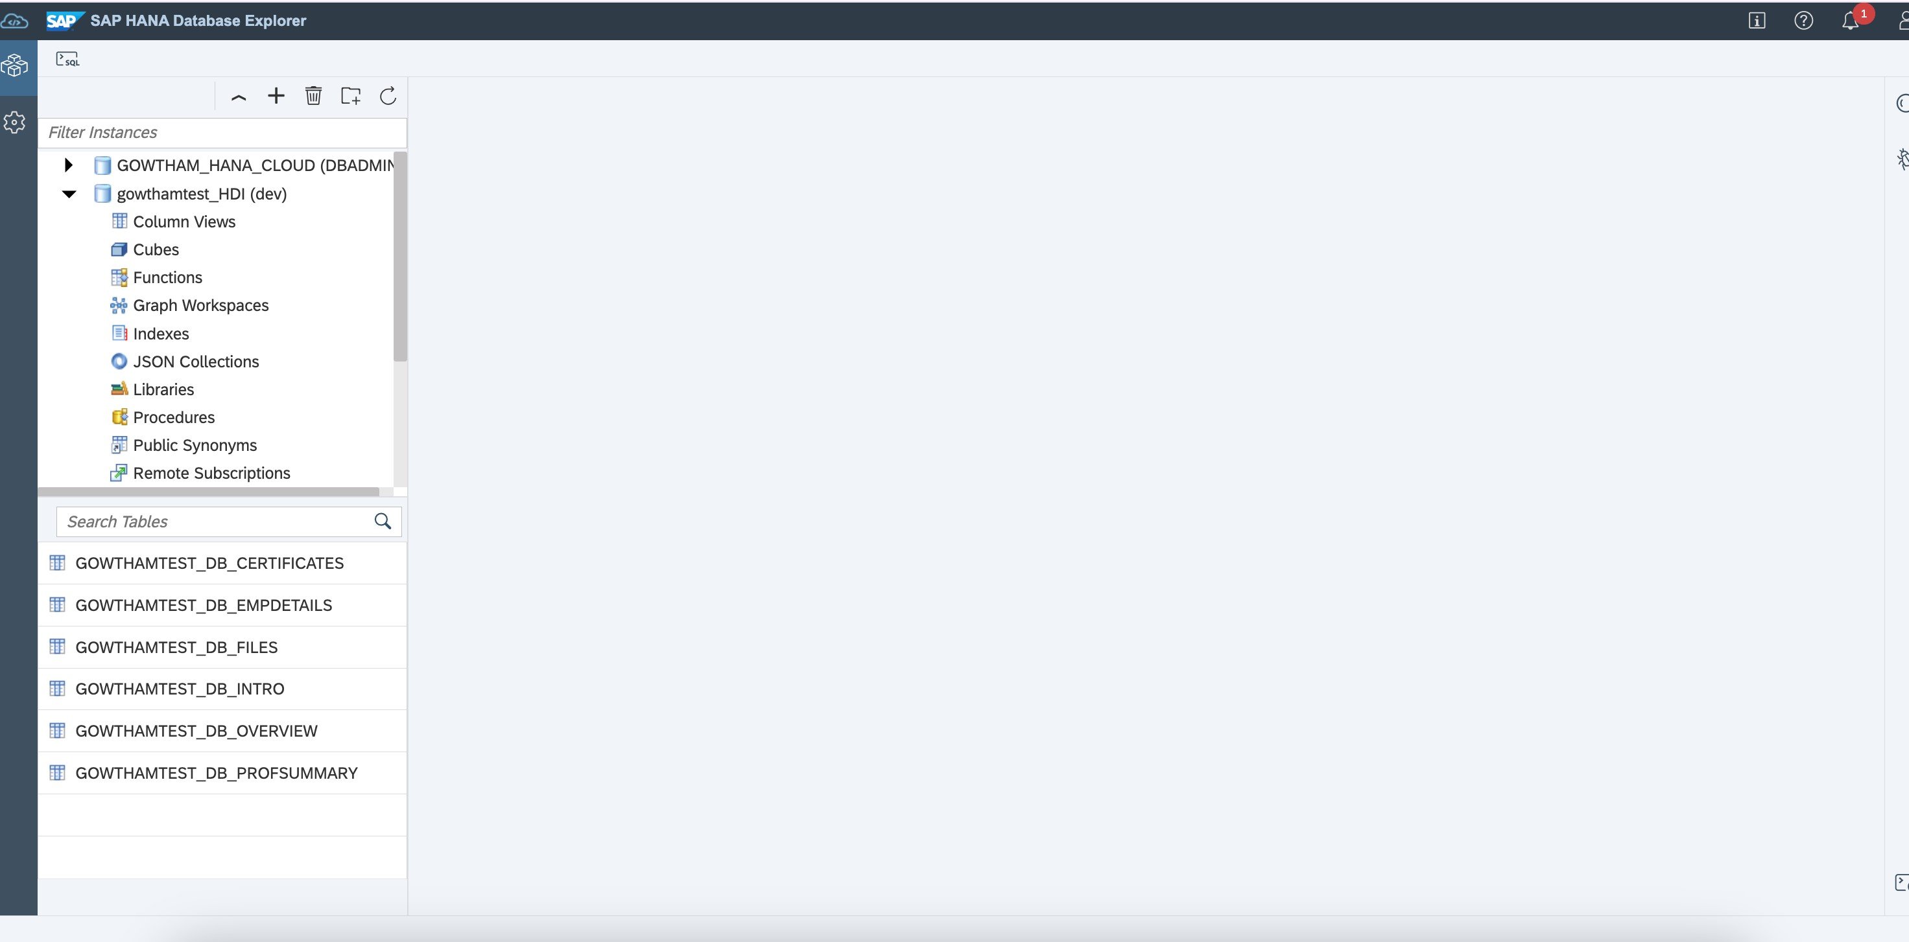

- Open dev space -> applications -> click gowthamtest-srv

-

Copy the link

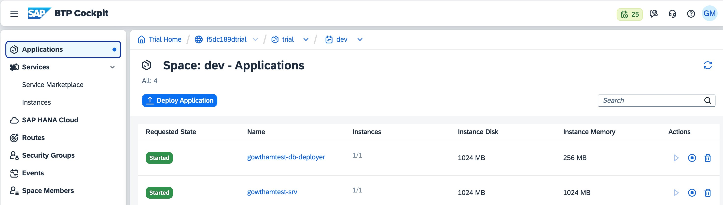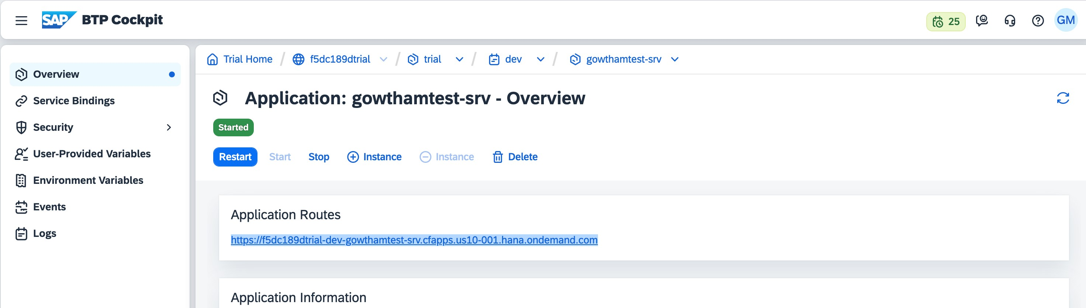

1. Create destination configuration in Btp cockpit



1. download the images available in webapp folder
2. In view.xml, attachment subsection-> make visible="true"
3. Right click the project and open terminal - Execute the below CLI cds bind -2 parthatest_HDI:parthatest_HDI-key
4. cds watch --profile hybrid, the app will open in new window.
5. Attachment section -> Now upload all the images
6. Now make the attachments section visible=“false”
7. Now refresh the browser twice
8. The app now will display the data from Hana cloud db

